Professor Matthew H. Brittingham
Emory University, PhD
Example Syllabus
m.h.brittingham@emory.edu

Transnational Religion and America

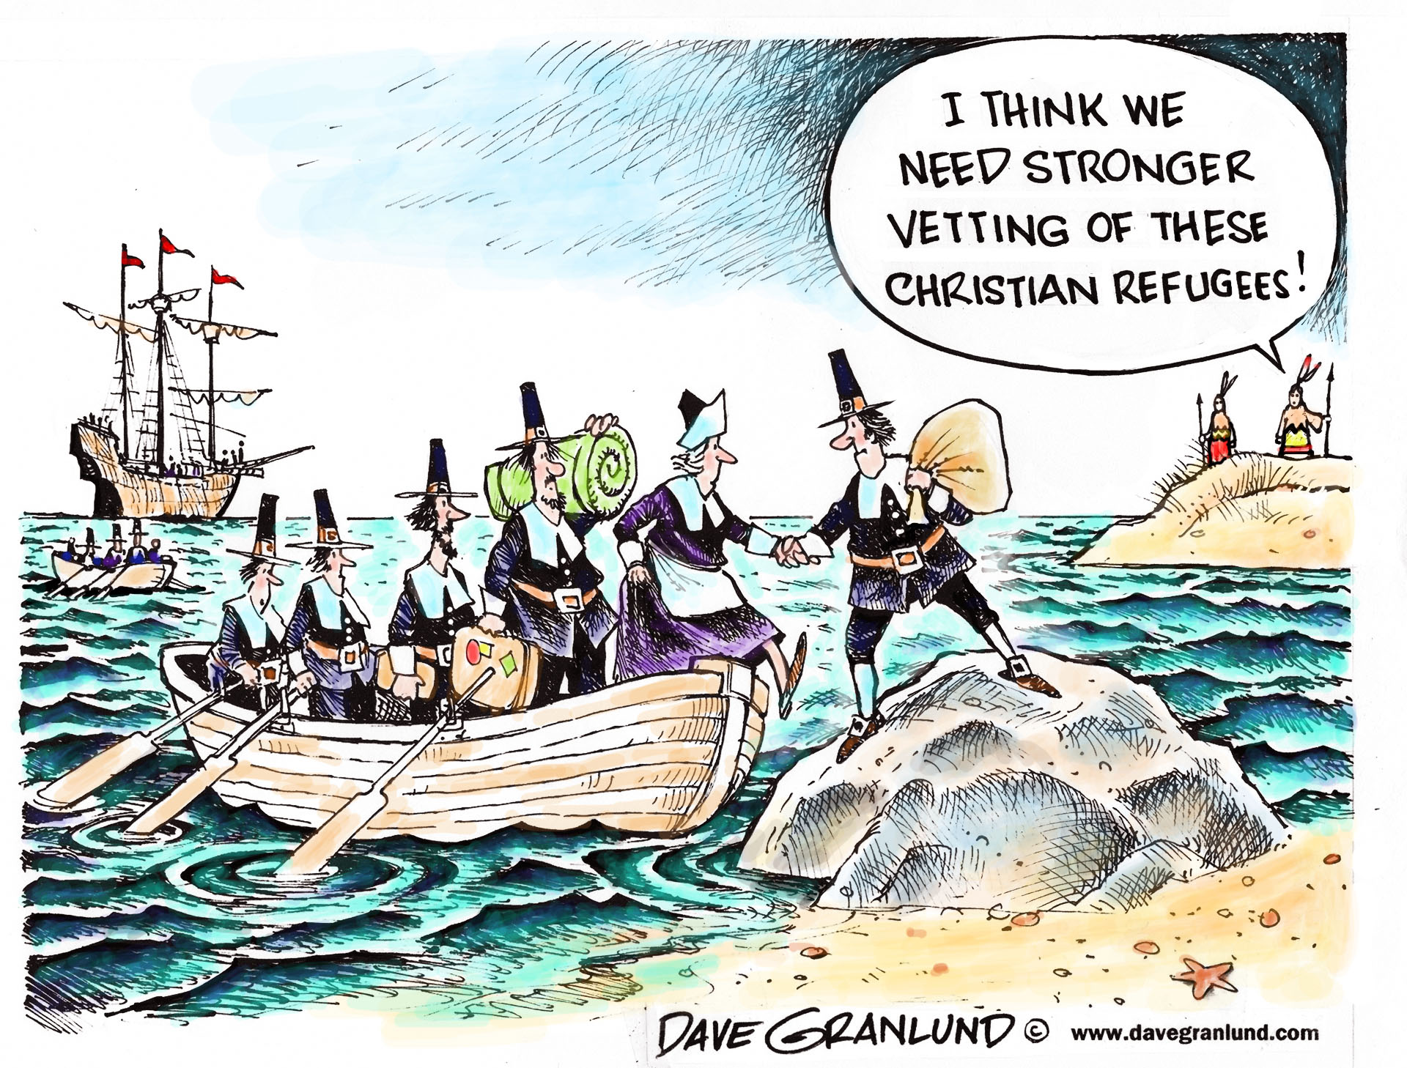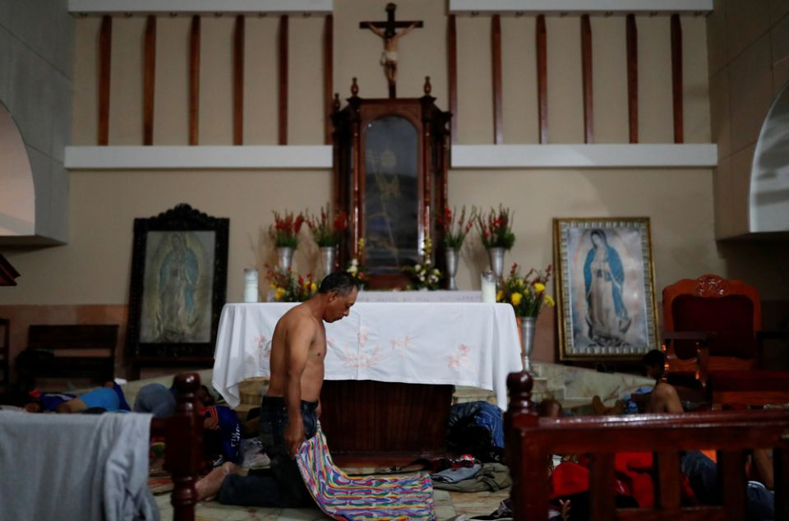

Every religion is a global religion. For those living in America, their religious traditions are no different. In this seminar, we will explore the religious, political, economic, and social transformations that take place when religious texts, traditions, and representatives travel across local, national, regional, and even religious borders. This seminar will cover a number of religious traditions, especially Islam, Buddhism, Judaism, and Christianity. Seminar readings will draw from anthropology, history, and religious studies to explore theories of mobility, modernity, translation, power, and more.

By focusing on America, our study can be applied contextually. America as a specific national context allows us to look quite narrowly at movement in and out of its borders. As religious people, texts, and traditions move in, out, and around the United States, they interact with happenings in the Americas, Europe, Africa, Asia, and Australia (so everywhere). We will not always focus only on America. Some of our methodological material is comparative or broader than the United States in its focus.

Week 1, Sept 1: Borders, Traffic, and Subjectivity
Readings:

- Selections from: Immigration and Religion in America: Comparative and Historical Perspectives, eds. Richard Alba, Albert Raboteau, Josh DeWind
- Russell Jeung and Jonathan Calvillo, “Race, Immigration, Ethnicity, and Religion in America.”

Week 2, Sept 8: More on Borders
Readings:

- Borderland Religion: Ambiguous practices of difference, hope and beyond, eds. Daisy L. Machado, Bryan S. Turner, Trygve Eiliv Wyller
- Selections: Transnational Traditions, eds. Ava F. Kahn and Adam Mendelsohn

Week 3, Sept. 15: Transnationalism and Modernity:

Readings:

- Religions, Nations, and Transnationalism in Multiple Modernities, eds. Patrick Michel, Adam Possamai, Bryan S. Turner.
- Selections from TransBuddhism: Transmission, Translation, and Transformation, eds. Bhushan et. al.

Week 4, Sept 22: Transnational Conceptual Analysis?
Readings:

- The Invention of World Religions, or, How European Universalism was Preserved in the Language of Pluralism, by Tomoko Masuzawa

Week 5, Sept 29: Comparative Perspectives

Readings:

Religion and Immigration: Migrant Faiths in North America and Western Europe, Peter Kivisto

Week 6: October 6: Comparatively (Trans-)National?

Readings:

Immigrant Faith: Patterns of Immigrant Religion in the United States, Canada, and Western Europe, by Phillip Connor

Week 7: FALL BREAK: Film

- Film: God Loves Uganda (TBD)
- Selections from: Christian Moderns: Freedom & Fetish in the Mission Encounter, by Webb Keane

Week 8, October 20: Transnational Networks:
Reading:

- Religion Across Borders: Transnational Immigrant Networks, eds. Helen Rose Ebaugh et al.

Week 9, October 27: Transnational Transcendence
Readings:

- Transnational Transcendence: Essays on Religion and Globalization, ed. Thomas Csordas.

Week 10, November 3: Pilgrimage of the Transnational:

Reading:

Our Lady of the Exile: Diasporic Religion at a Cuban Catholic Shrine in Miami, by Thomas Tweed.

Week 11, November 10: Transnationals ‘In American’
Readings [chose one]

- God in Chinatown: Religion and Survival in New York’s Evolving Immigrant Community, by Kenneth Guest.

Black Mecca: The African Muslims of Harlem, by Zain Abdullah.

Week 12, November 17: Unseen Movements in the American

Readings:

Out of Place: Social Exclusion and Mennonite Migrants in Canada, by Luann Good Gingrich.

Week 13, November 24: A View from the Other Side:

Reading:

- Evangelicals and Immigration: Fault Lines Among the Faithful, by Ruth M. Melkonian-Hoover and Lyman A. Kellstedt.

Week 14, December 1: Presentations

Week 15, December 8: Presentations

Final Paper Due: Dec. 15 by email.

Book reviews (due Oct. 6 and Nov 3):
You are required to turn in two book reviews for the course. Choose whatever books you want in your field. The books must be 1-2 years old and must fit a journal in which you might possibly submit a review. Do your reviews to the specifications of the journal(s) to which you would send a review. Word limit is around 1000 words. Remember to use the correct format, which often includes the title, author, and publication info. You should provide a concise synopsis of the main argument, the content of several (if not all) chapters, and point to the contributions to the wider field, and indicate which field(s) they are (e.g. religious studies, area studies, discipline-specific etc.). Indicate what level the book might be useful in the classroom. Your last section should posit some sort of critique. Remember that tone and style matter. You are introducing yourself as a scholar, not just the book.

Foundational Theorist Presentation (Nov. 10; 15-20 minutes): With this assignment, you are required to explore a major theorist of your choice and for the benefit of the class. You should choose someone who has made a significant impact on the field/sub-field of your choice. Such a theorist may come from outside of religious studies (i.e. philosophy, sociology, anthropology, political science, or linguistics), but might be influential on the theory and practice of religious studies. In your preparation for this presentation you should read one signature article (or chapter-length excerpt of her/his work) and at least one article or chapter on the significance of the idea developed in this excerpt. More than one person may present on a given theorist. The goal of your presentation is to teach your classmates about this theorist and the contribution to theoretical debates in the study of religion. A two-page synopsis of your presentation (no longer) should be submitted to me the night before your presentation.

Paper Presentation (Dec. 1 & 8): Paper presentations are part of your grade as well. You can do a PowerPoint or a traditional paper reading. We will treat these class days as though you are at a graduate conference, which accept many different forms of paper presentations. You will be presenting your final paper project and will receive feedback from fellow students and myself. We want your papers to be improved by testing your methods, presentation style, arguments, and evidence.

Final Paper (Dec. 15): Your final paper is, typical of most graduate seminars, of your choosing. The final paper is due December 15, but final paper abstract, outline, bibliography are due October 27. The abstract, outline, and bibliography do not need to be perfect, but should show your approach, evidence, and argument. I will disperse the abstract, outline, and bibliography to fellow students, who will comment on them by Nov. 7. We will then workshop what the class has done on Nov. 10. If you need help deciding on a final paper topic or an approach to a final paper project, let me know and we can figure something out.

Grade Breakdown
Book review (1000 words): 20%
Theorist/Theory Presentation (15-20 min): 20%
Final Paper abstract, outline & bibliography: 10%
Final Paper: 50%

Please note: Within the first two weeks of class, you must tell me of any need for special allowances related to note taking, assignments, or tests (ex. extra time or formatting). Only authorized documentation from the office of student affairs will be accepted for special allowances.

