Matthew H. Brittingham
m.h.brittingham@emory.edu

Lecture: M/W 10:00-10:50am
Discussion Sections: F 10:00-10:50am

JS 101/History 185/RELS 170
Introduction to Jewish Studies:

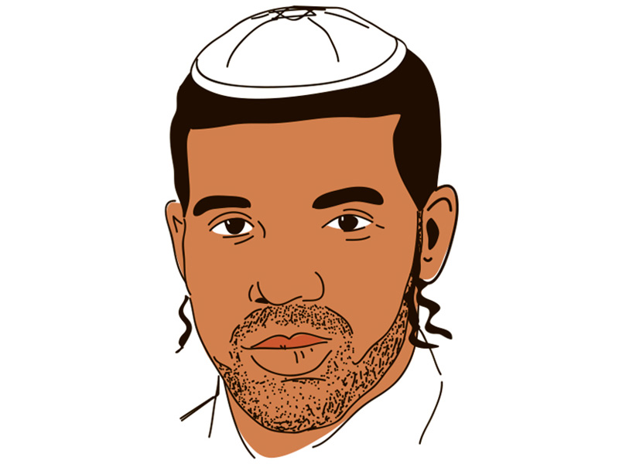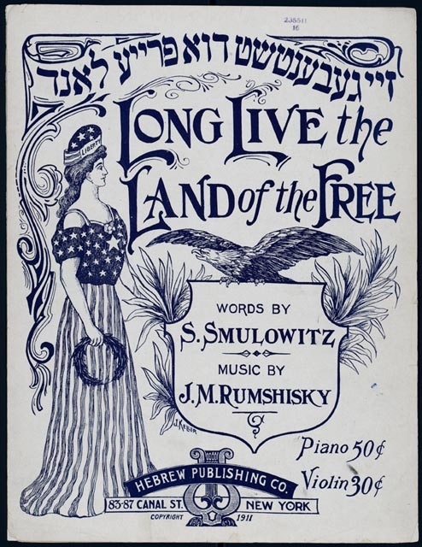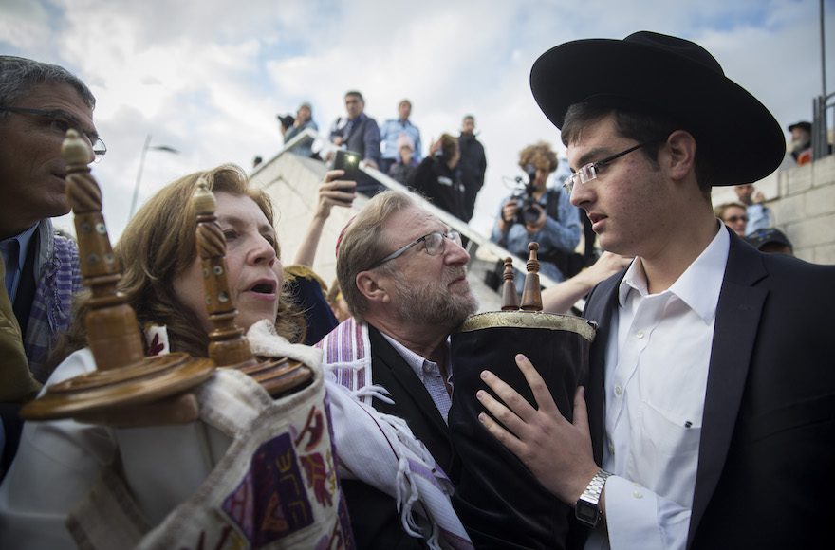

Description and Details

This course introduces students to the various questions, texts, methodologies, and perspectives that constitute the broad field of Jewish Studies. No prior knowledge of Jewish history, religion or culture required.

We will study Jewish beliefs, practices, and history from the biblical period to the present. The diversity of Jews and Judaism—according to geography, gender, and religious expression—will be emphasized. We will pose several critical questions about the definition of Jews and Judaism—are Jews a people with a shared history based on collective experiences? Or, are they a religious group, situated around a common set of beliefs and rituals? Or, are Jews an ethnic group, defined so by their common culture? Rather than imposing any one definition, we will track the diversity of Jewish civilization from antiquity to the present, especially how many Jews have answered the above questions in different ways. We will use a range of academic perspectives when analyzing diverse Jewish experiences and expressions. As we study the history and texts of Jewish civilization, we will constantly return to two recurring themes: shifting notions of “diaspora” and “homeland,” and the boundaries of Jewish identity.

Required Texts: Can be found at the university bookstore or at the library (course resevere)

- Burton Visotzky and David E. Fishman, From Mesopotamia to Modernity: Ten Introductions to Jewish History and Literature (1999)
- Christine Hayes, The Emergence of Judaism: Classical Traditions in Contemporary Perspective (2011)
- Harvey E. Goldberg, Life of Judaism (2001)
- Heritage: Civilization and the Jews—Source Reader, eds. Hallo, Ruderman, Stanislawski (1984)
- L. Batnitzky, How Judaism Became a Religion: An Introduction (2011)

Grading:

Attendance and Participation 20%
3 Short Written Assignments
(15% each; see syllabus) 45%
In-class exams (Midterm 15%, Final 20%) 35%

For work submitted late without documentation, I will grade down by a letter grade for each day it is overdue.

Extra Credit: 2%, attend and submit a short write-up (1-page) on a faculty lecture related to Jewish studies. Write-up due within 48 hours of event.

A Note on Preparedness:

Attendance and participation grade hinges on your active discussion in class. Our discussions in class will assume your familiarity with the texts and basic comprehension from a deep reading. In general, you will be most successful in this class if you are prepared. That means, do ALL the readings, think deeply about the material, come with thoughts or questions, and be ready to listen and take notes. Doing the required readings will not only help you participate in class and perform well on tests, but it will also make the class much more engaging, lively, and fun. Actually reading will also help you think deeper about what we are learning in class, as the lectures in class will not be a summary of the readings. If you do the readings and think about the material, you will come with substantive questions and comments that will get you the most participation points. One way to participate is to observe the classroom rule: no computers, no cell phone...unless you have a specially dispensation from the office of student affairs (see below).
Students with Disabilities:
Any student with a university-documented disability should contact the professor within the first two weeks of class. Only authorized documentation from the office of student affairs will be accepted for special allowances.

Honor Code:

All students are expected to abide by the university’s honor code, which prohibits all forms of academic dishonesty, including cheating and plagiarism. The honor code is in effect throughout the semester. By taking this course, you affirm that it is a violation of the code to cheat on exams, to plagiarize, to deviate from the teacher’s instructions about collaboration on work that is submitted for grades, to give false information to a faculty member, and to undertake any other form of academic misconduct. You agree that the teacher is entitled to move you to another seat during examinations, without explanation. You also affirm that if you witness others violating the code you have a duty to report them to the honor council. Please review the honor code at the following site: http://college.emory.edu/home/academic/policy/honor_code.html.

Classroom Etiquette:

- Do not assume any previous knowledge of anyone in the class. Always define your terms.
- Bring texts read for class that day.
- Computers: The use of computers/IPads etc. is not allowed in class. Only students with a university-documented disability will be allowed to take notes on a computer.

Short Written Assignments:

- Source Analysis on Home and Diaspora (Due Mar 18, 1.5-2pp): How have Jews created “home” in diaspora? Analyze and compare/contrast two sources. Sources to Consider: Polish Jewish Legends of Origin, Sampson Simson on Jews in America.

- Movement/Lifecycle Presentation and Paper (Due Apr 8, 3pp): Pick a Jewish lifecycle event or a movement. For a lifecycle event: how have Jews constructed meaning out of history through life events, and in what ways are individual life cycle events linked to the social and cultural settings in which they are enmeshed? Some Lifecycle events: Circumcision, Baby Naming, Rituals of Education, Death, Mourning. For a movement: how has the movement you selected played a role in defining Jewish identity? How do on-the-ground realities complicate the idea that adherents always follow the movement’s definition of Jewish identity?

- Book Review (Due Apr 27, 4-5pp): Pick Jewish studies book from list of library books to be distributed by the professor in early April. What is the book’s main argument? What is the author’s method of analysis or approach? How does the book intersect themes and discussion we have previously had in class? What are the similarities in argument and approach to the literature we have read for class?

Course Schedule:

Part I: Genealogy of the Study of Jews and Judaism

Wed, Jan 16: Introductory work: terms, sources, dates; discuss our framing questions

Fri, Jan 18: Discussion section: Students come prepared to define key terms in Jewish studies and the study of Jews and Judaism

Reading: Hayes, “Preface”, ix-xii.

Monday: University Holiday

Wed, Jan 23: The Birth of Jewish Studies:
Reading: Jacob Neusner, “Jewish Studies and the New Humanities.”

Fri, Jan 25: Discussion: Who, when and why did scholars want to study the Jews “academically”?
Documents: *Jew in the Modern World: 233-235 (intro), #2 Statutes, Society for the Culture and Science of the Jews, 1822 (238-39), #4 On the Concept of a Science of Judaism, 1822 (244-245), #6 Leopold Zunz, 1832 (254-255), #9 Samson Raphael Hirsch, 1855 (260-261).

Part II: Ancient Texts and Israelite Culture

Mon, Jan 28: Ancient Israelites: Ancestors of the Jews
Reading: Hayes, 1-14, 25-38.

Wed, Jan 30: Biblical Literature
Reading: From Mesopotamia to Modernity (FMM), 9-36.

Fri, Feb 1: Discussion: Ancient Israel and the Ancient Near Eastern Context
Reading: Hayes, 39-71.
Documents: Heritage, “The Flood”, “The Birth of Moses”, “The Covenant at Sinai”.

Mon, Feb 4: Diaspora and the Beginnings of Judaism/Canonization
Reading: Hayes: 14-23, 77-82.

Wed, Feb 6: Second Temple Judaism(s):
Reading: FMM, 37-54; Hayes, 82-88.

Fri, Feb 8: Discussion: Home vs. Galut (Diaspora); Creating “Jewish” Borders—Ezra and the Intermarriage Issue
Documents: Heritage, “Two Views of the Exile” (Psalms & Jeremiah), “The Edict of Cyrus”, “The Egyptian Diaspora”, “The Problem of Intermarriage”.
In-Class Discussion Question: Hayes, 88, #1: Compare and contrast the views of Jewish intermarriage presented in the books of Ezra and Ruth. How can the presence of both viewpoints in the Hebrew Bible be understood?

Mon, Feb 11: Rabbinical Judaism during the Second Temple and Beyond
Reading: Hayes, 89-123 (skip “From a Classic Text”: 5.1, 5.2, 5.3).
Document: Heritage, Yohanan ben Zakkai’s Prescription for Jewish Survival.

Wed, Feb 13: Rabbinic Literature and the Origins of Christianity
Reading: Hayes,125-143; FMM, 71-83 (skim 92 “Targum”-top 100).
Documents: *Talmud Berakhot; Heritage, “Josephus on Jesus.”

Fri, Feb 15: Discussion: The Rabbis, Creating their Authority; Birth of the Convert and Matrilineal Descent
Documents: Hayes, “From a Classic Text”: 5.1 “Rabbinic Myth of Origins”, 99-101; 5.2 “The Transmission of Torah”, 103-105; 5.3 “Midrashic Virtuosity”, 107-108.

Mon, Feb 18: Jews under the Crescent: Facts and Fictions
Reading: FMM, 103-126.
Documents: Heritage, “Pact of Umar”, “Nathan the Babylon on the Installation of the Exilarch.”

Wed, Feb 20: Medieval Jewries: Sephardi vs. Ashkenazi
Reading: Hayes, 145-150; FMM, 167-180.

Pick book related to Jewish Studies for paper #3 [selected from a list and discuss the book choice with me]

Fri, Feb 22: Discussion: Saadia’s Proof of God and Responses; Blood Libel in Christian Europe
Documents: Heritage, “From the Book of Beliefs and Opinions of Saadia Gaon”, “Karaite Refutation of Saadia’s Defense of Rabbinic Judaism”, “Accusation of Ritual Murder at Blois”, “Solomon Ibn Adret on the Place of Philosophy and Mysticism in Judaism.”

Handout for paper on Home/Diaspora available

Mon, Feb 25: Modern Jewries: When does Modern Jewish History begin?
Reading: Hayes 150-154; FMM, 181-206.
Michael Meyer http://www.jewishideasdaily.com/5770/features/where-does-the-modern-period-of-jewish-history-begin/

Wed, Feb 27: Modern Judaism(s)
Reading: *Dana Evan Kaplan, “Contemporary Forms of Judaism.” & L. Batnitzky, Chapters 1-2.
Documents: Heritage, 222-226, 227-229, 255-256.

Fri, Mar 1: Discussion: Israel and Jewish Identity: Who’s a Jew in modern Israel?
Reading: L. Batnitzky, Chapters 8-9.
Documents: google books: Asher Felix Landau, Select Judgments of the Supreme Court of Israel- Rufeisen Case (pp1-13); Neturei Karta— www.nkusa.org/.

Mon, Mar 4: Modern Judaism(s) #2
Reading, L. Batnitzky, Chapters 6-7.

Paper on Home/Diaspora (see handout) Due

Wed, Mar 6: Midterm Review

Fri, Mar 8: No Discussion Sections/Midterm:

Mon, Mar 11-Fri Mar 15: No Class—Spring Break

Part III: The Life of Judaism and the Jewish Life Cycle: Time and Context

Mon, Mar 18: Movements and Identities: Denominationalism
Reading: Goldberg, 1-12 (Introduction), 51-76 (Frida Kerner Furman, “Synagogue Life among American Reform Jews”) (Samuel C. Heilman, “Orthodoxy in an American Synagogue”).

Handout for paper on Rite/Movement available

Wed, Mar 20: Movements and Identities: The Havura Movement
Reading: Goldberg, 79-91 (Chava Weissler, “Worship in the Havura Movement”).

Fri, Mar 22: Discussion: Spaces and Texts of Jewish Life—“Movements” and Religious Complexity
Documents: compare/contrast Jewish text, ritual, identity in Reform, Orthodox, and Havura movements from the Goldberg readings related to these movements.

Mon, Mar 25: Secular Jewish Movements: Zionism, Jewish Socialism, Yiddishism, etc.
Reading: TBA

Wed, Mar 27: Movements and Identities #2: Race, genes, and migration:
Reading: Shaul Stampfer, “Are we all Khazars Now?”, Jewish Review of Books (Spring 2014)—http://jewishreviewofbooks.com/articles/802/are-we-all-khazars-now/
Goldberg, 227-240 (Hagar Salamon, “Ethiopian Jewry and New Self-Concepts”)

Fri, Mar 29: Rites of Passage: Case Study: Bar/Bat Mitzvah
Reading: *Goldberg, “Being Jewish”, 1-5; Goldberg, 121-135 (Fran Markowitz, “A Bat Mitzvah among Russian Jews in America”).

Mon, Apr 1: Rites of Passage: Case Study: Marriage
Reading: Goldberg, 105-119 (Einat Ramon, “Tradition and Innovation in the Marriage Ceremony). & Goldberg, 114-136, 147-160.

Wed, Apr 3: Rites of Passage: Case Study: Death
Reading: TBA

Fri, Apr 5: Discussion section presentations: Rite of Passage/Movement (5-7 minutes each presentation)

Mon, Apr 8: In-Class Discussion: Passover—Rites and Gender
Reading: Goldberg, 29-49 (Irene Awret, “Preparing for Passover in North Africa”) (Susan Starr Sered, “Religious Roles of Elderly Women”).

Rite of Passage/Movement Paper Due

Part IV: Jewish Identity and Change in Modern Times

Mon, Apr 11: Popular Culture and Its Impacts:
Reading: Jeffrey Shandler, “Jewish Popular Culture”.

Wed, Apr 13: Popular Culture and Its Impacts #2:
Readings: TBA

Fri, Apr 18: “Home” and Jewish Culture in the Modern Age: Pilgrimage and Creating Identities
Reading: Goldberg, 173-211 (Danielle Storper Perez and Harvey E. Goldberg, “Meanings of the Western Wall”) (Yoram Bilu, “A Moroccan Jewish Shrine in Israel”)

Mon, Apr 21: Modern Jewish Homelands: Zionism, Diaspora Nationalism, Birobidzhan, Kiryas Joel
Documents: Heritage, 234-238.

Wed, Apr 23: Modern Jewish Homelands #2: In-class discussion: Home and its Meaning:
Reading: Review readings for the week
Start reading Maus I

Fri, Apr 25: Holocaust: Memory and Meaning
Reading: Goldberg, 149-171 (Schorsh and Feldman, “Memory and the Holocaust: Two Perspectives”). Continue reading Maus I
Documents: Heritage, 269-276.

Wed, Apr 27: Inheriting the Holocaust: Memory and Meaning #2: Postmemory
Readings: Finish Maus I

Paper #3 Due: Book Review Paper

Fri, Apr 29: Closing and Wrap-up

Final Exam: Tuesday, May 5, 8:00am-10:30am

