Writing Assignment: Example
Introduction to Jewish Studies

Short Analysis Paper: Home and Diaspora

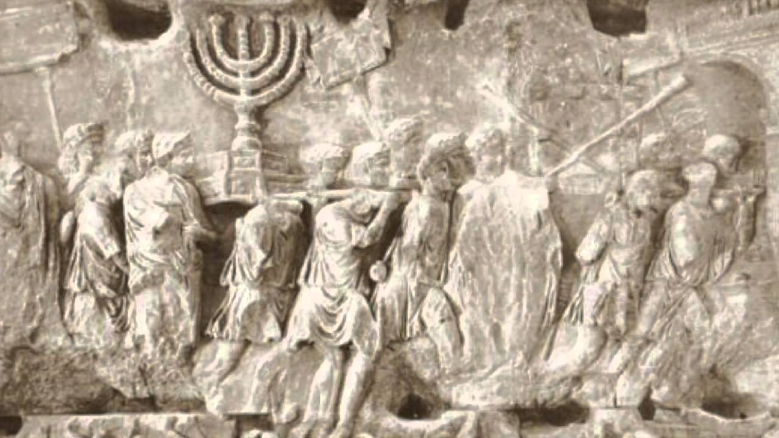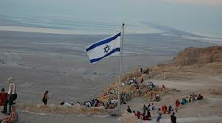

For this assignment you will reflect on the theme of Home and Diaspora in Jewish Studies. In our course, starting with the Babylonian exile (586 BCE), we explored the birth of the Jewish diaspora and found that this diaspora continued long after the Restoration period, even into the rebuilding of the Second Temple in Jerusalem under Persian rule. Therefore, from the very beginnings of exile a tension was born: (A) the traditional Jewish hope for overcoming exile and (B) the reality of Jews making a home in the diaspora. We read about this tension in biblical traditions, namely in the Psalms and from the prophet Jeremiah. Both sources presented different reactions to exile and the possibility of creating home in the diaspora.

For your first writing assignment, I ask you to analyze how Jews have created “home,” or the conditions of home, in the diaspora. You will use primary sources from other contexts—other times and other places—in the Jewish past. Choose from 1 of the following 2 sources:

- Polish-Jewish legends of origin (2 different origin stories are on Blackboard—please use both)
OR
- American-Jewish heritage stories: Sampson Simson on Jews in America (See syllabus for location of the source)

The point of this assignment is to see the tension between home and diaspora as it becomes manifest in different times and places in Jewish history. Through the source analysis you will see how Jews have attempted to analyze, articulate, and argue anew their feeling of “home” or their desire for belonging.

You will need to analyze what this source (1) communicates about the hopes and dreams of its author(s), (2) how it relates to the conditions of Jewish life in the diaspora [in which Jews were often viewed as outsiders], and (3) in what ways it attempts to legitimize Jews feeling “at home” in the diaspora.

After this initial analysis, compare the source to the Psalms/Jeremiah readings we previously addressed. Answer: What is similar? What is different? How can you account for the continuities and discontinuities in the ways that Jews have communicated their sense of being at “home” or in “diaspora,” from the ancient to modern periods?

Guidelines:
- 1.5-2 pages (650 word) essay, typed, double-spaced, 12-point font, 1-inch margins, with page numbers and your name.
- Only use 1 of the 2 new primary sources listed above, in addition to the Psalms/Jeremiah sources. You can only use secondary sources assigned from our course for background material on Jewish life in medieval Poland or modern America. Realistically, you should still focus most of your writing and attention on the primary sources. In other words, do not write with too many references to our course’s secondary sources.
- Cite your sources: Use parenthetical citations at the end of a sentence before the final period, citing the author or title of the work and the relevant page number(s). For example: (Psalms 50:3-4). You must cite quotes, paraphrases, and when you draw on writings from another author.
- Your grade will take into account content and style—in other words, what you say and how you say it matter. Edit and proofread your paper—this will improve the quality of your writing and your grade!

