Radicals, Rabbis, and Everything In-Between:
American Jewish Literature from the 1880s to the 1930s

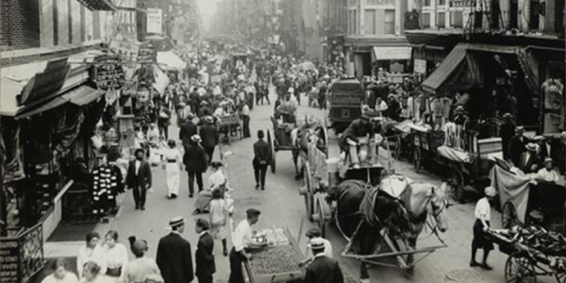

Course Description:

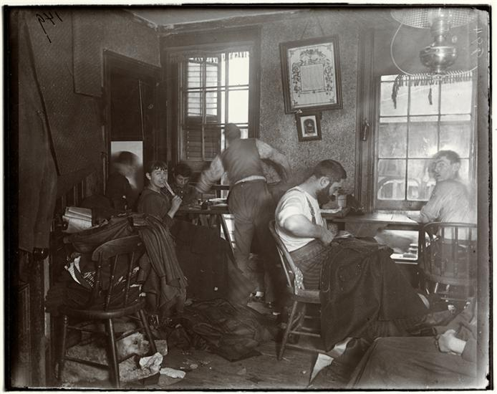
Between 1880-1924, approximately 2.5 million Jews arrived on American shores, the vast majority coming from Eastern Europe. This “great wave” of Jewish immigration to the United States, part of broader period of human mass migration, forever changed the contours of the American Jewish community. In 1880, there were about 250,000 Jews in the United States. By 1920, there were about 3.5 million. The particularities of the United States (which we will discuss) encouraged these Jewish immigrants to acculturate to their new home by creating their own immigrant Jewish culture in their own language—Yiddish. The flourishing of Yiddish culture in the large urban centers of the American Northeast and Midwest included socialists, communists, rabbis, popular Orthodox writers, housewives, freethinkers, deists, and more. The themes and genres are similarly diverse—working-class tensions, religious-devotional reading, pop-romances, poetry, modernist fiction, etc., etc. Increasingly, Yiddish speakers and their children published in English or had their works translated.

In this class, we will discuss the treasures trove of literature that came out of this great wave of immigration from Eastern Europe. We will divide our time between Yiddish works in translation and Yiddish speakers who wrote directly in English. We will read and/or discuss some of the most famous Jewish writers from this period, such as Morris Rosenfeld, Mary Antin, Anzia Yezierska, Abraham Cahan, Mike Gold, and Henry Roth. However, we will also discuss writers who aren’t nearly as well known, since they have had little of their work translated from Yiddish.

General Policies

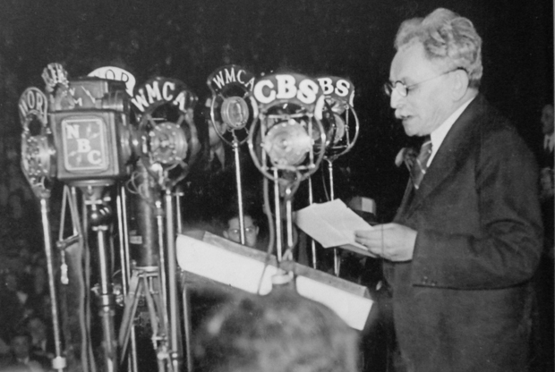
Attendance will be taken immediately after the end of add/drop/swap.
University sanctioned absences: If you are student athlete, in ROTC, or have another university sanctioned event, please notify the professor immediately. If a university sanctioned event is requested for an excused absence you must have proper documentation. Family events (funerals, weddings, etc.), religious holidays not in accordance with the University’s academic calendar, and other special occasions are subject to the professor’s approval. Potential absences must be excused prior to their occurrence.
Contesting Grades: I do my best to ensure that your work is graded fairly, honestly, and clearly. Nonetheless, I recognize that occasionally there will differences of opinion concerning an appropriate grade. I want you to follow the following protocol for contesting a grade:

•WAIT 24 hours from the time it was handed back before contacting the professor.
•TYPE out the reason you believe the grade does not accurately reflect your performance in the class and email it to me. We will then arrange a meeting and you will bring a hard-copy of what you typed up, along with the original work, to our meeting. If you make an appointment for specifically discussing a grade, note that a grades may be raised, sustained, or lowered.
Academic Dishonesty: Plagiarism or cheating will not be tolerated and will be reported. Your papers will go through a rigorous online system to double-check for plagiarism. You will find the University’s statement on Academic Dishonesty on the Student Affairs website.
Policy on Argument, Belief, and Opinion: We all come to this course with different assumptions, experiences, and backgrounds. I encourage disagreement and debate, but I ask that you disagree with one another in a respectful manner. Diversity of opinion is not tantamount to disrespect. But, precisely because of the diversity of opinions represented in this class, we must use the material as our common ground and reference point. Likewise, I will do my best to treat with respect the potentially difficult issues arising from class materials or discussions. Be patient with others even if you don’t agree with them or want to inform them that they are simply wrong—in a respectful and constructive manner, of course. Please do not take the license for disagreement and debate as an opportunity to preach particular theological positions or attack anyone for any reasons.

Grades and Grading Policies:

Late assignments: late work will be deducted at the rate of 10% per day late.
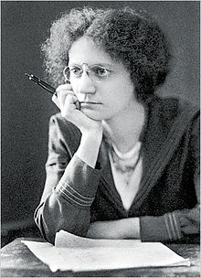
Students are responsible for checking the online system and making sure that all inputted grades accurately reflect the grade on your returned work.
Curve: There will be no curve in this course.
Grade Breakdown:
Class attendance and participation: 25%

- Generally speaking, it will be fairly easy for me to tell if you haven’t done the assigned readings. If need be, I will start asking for reading quizzes, though I really don’t want to be forced to do that.

Response paper: 10%
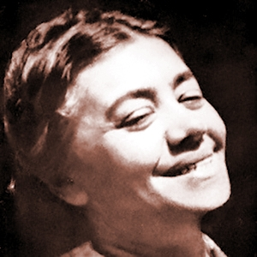
- Compare Salome of the Tenaments as a book and as a film (700 words)

Presentation, Class Discussion, and Presentation Paper: 20%

- Each student (or groups of students) will have the responsibility of signing up for a given day’s readings and posing several questions to the class (the Sunday before class)

Final paper project: 45%: 10-13 pages

- Choose one text we have read in class and do a deep dive into a particular theme of that text—compare it to other works we have read this semester.
  - This is a scaffolded project:
    - By week 7 you should have a theme or text that interests you
    - By week 9 you will be required to turn in a “paper proposal”—to be discussed. The proposal will show your theme and text, and include other resources you want to use.
    - By week 11 you are required to turn in a 5 page draft (at least, more is always better)
      - I will read your draft and provide extensive feedback within 1-2 days.

    - Final paper will be due on the day when the college assigns the final exam.

Class Topics and Dates:

Week 1: America Before and After the “Great Wave” and the Beginnings of Yiddish Literature in America
- Eric Goldstein, “The Great Wave” from The Columbia History of Jews and Judaism in America (Canvas)
- Eric Goldstein, “A Taste of Freedom: American Yiddish Publications in Imperial Russia,” from Transnational Traditions (Canvas)
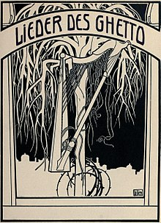

Week 2: Sweatshop Poets and Socialist Print Culture:
- Morris Rosenfeld and Leo Wiener, Songs from the Ghetto (library, online, or purchase)
- Avraham Novershtern, “Yiddish American Poetry,” from The Cambridge History of Jewish American Literature (Canvas)
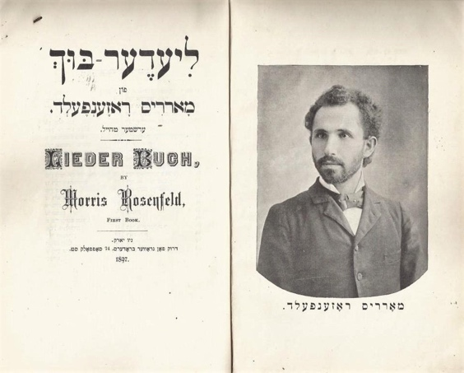
- Tony Michels, “Speaking to “‘Moyshe’: Socialists Create a Yiddish Public Culture,” from A Fire in Their Hearts: Yiddish Socialists in New York (Canvas)

Week 3: The Tensions of American Life:
- Abraham Cahan, “Yekl: A Tale of New York,” and selections from “The Imported Bridegroom” (library, online, purchase)
- Werner Sollors, “Immigration and Modernity, 1900-1945,” from The Cambridge History of Jewish American Literature (Canvas)

Week 4: Women’s Voices in Autobiography and fiction:
- Mary Antin “The Promised Land” (library, online, purchase)
- Anzia Yezierska’s “Salome of the Tenements” (library, online, purchase)

Week 5: Women’s Voices in Autobiography and Fiction: (continued)
- Continue with Antin and Yezierska
- Watch: Salome of the Tenements (film)
  - Response paper due 3 days after the film viewing

Week 6: Women’s Voices in Poetry:
- Selections from Anna Margolin and Celia Dropkin (Canvas)
- Kathryn Hellerstein, “Gender Poetics in Jewish American Poetry” (Canvas)
Week 7: Poetry and “Highbrow” Art:
- Selections from “Di Yunge” and “In-Zikh” (Canvas)
  - Have an idea for your final paper (discuss in class)

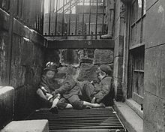

Week 8: Making it in America? I:
- Abraham Cahan’s “The Rise of David Levinsky” (library, online, or purchase)

Week 9: Making it in America? II:
- Anzia Yezierska’s “The Bread Givers” (library, online, or purchase)
  - Turn in paper proposal

Week 10: American Antisemitism: The Promised Land in Question?
- Gil Ribak, “‘You Can Recognize America’: American Jewish Perceptions of Anti-Semitism as a Transnational Phenomenon after the First World War” from American Jewry: Expanding the European Experience (Canvas)
- Selections from A.D. Oguz’s “The Freethinkers” (Canvas)

Week 11: The Decline of Yiddish, the Growth of English, and the Future of Immigrant Jewish Literature
- Goldstein, “The Struggle over Yiddish in Postimmigrant America” from 1929: Mapping the Jewish World (Canvas)
- Henry Roth’s Call It Sleep (library or purchase)
  - Five page draft due.

Week 12: Where the Tentacles Go:
- Gabriella Safran, “Patterning a New Life: American Jewish Literature in 1929” from 1929: Mapping the Jewish World (Canvas)
- Benjamin Schreier, “Making It into the Mainstream, 1945-1970” from The Cambridge History of Jewish American Literature (Canvas)
- Selections from Michael Gold’s Jews Without Money (Canvas)

