Matthew H. Brittingham
m.h.brittingham@emory.edu
Office: 213S Callaway Hall
Office hours: Monday 2pm-4pm, or by appt.
Sample Syllabus

REL490:
Advanced Theories and Methods in Religious Studies, Senior Seminar

Tuesday, Thursday, 2:00-3:15pm

“The Bible’s blind, the Torah’s deaf, the Qur’an’s mute
If you burned them all together you’d get close to the truth,
Still, they’re pouring over Sanskrit under Ivy League moons,
While shadows lengthen in the sun…”

—Bright Eyes, “Four Winds”

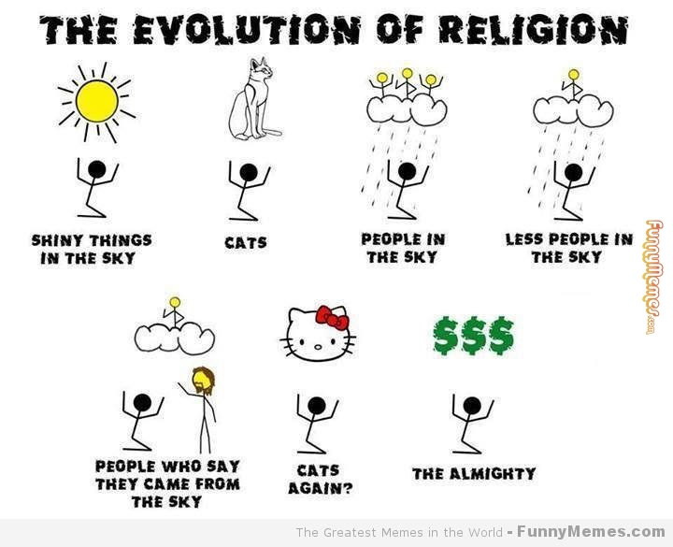

Course Description:

“Religion” shows up everywhere. It’s in songs, memes, television, billboards. But what is it? An experience? A social phenomenon? A byproduct of other neurological processes? How have scholars defined “religion”? How has use of “religion” developed? What is the term’s history? To explore these questions, this course will be divided into two parts. The first will analyze classic theorists of religion (Otto, Freud, Durkheim, Eliade, etc.) and the various methods they used to address religion: psychological, sociological, anthropological, phenomenological, etc. Second, we will consider the implications of various definitions of “religion” as they have been applied to subfields or subthemes within the study of religious, such as gender, civil religion, popular culture, embodiment, etc. How do these areas and fields expose limits or benefits of various definitions of “religion”?

In this course, we will read the classics—mostly dudes long dead by now—and some of the latest theorists who have critiqued them. Through this combination of the new and old, we will struggle with “religion” and its genealogy, just as many other scholars have. To wrestle with “religion,” we will look at how more recent scholars have applied classic theories and thinkers to a particular tradition(s), i.e. Buddhism, Islam, Judaism, etc. It is your job to make these readings and subfields speak to each other, just as it is also your job to bring your expertise and previous study of religion to bear on the class. It will be a lot of reading, thinking, and writing from week to week. We will take it slow while working on other issues related to the profession of religious studies. Trust me, we will have fun!

Some Course Objectives:
  - To be able to summarize and critique classic theories in the study of religion.
  - To discuss and workshop with fellow classmates the difficulties facing a variety of subfields, methods, and theories
  - To write brief summary reviews of complicated arguments
  - To learn how to write a longer seminary paper in religious studies

Course Requirements:

Attendance and Participation: 15%
Each student is required to attend regularly and participate in class discussion. Students are allowed one undocumented absence before absences start counting against attendance and participation grade. Participation includes being prepared each day for class by having read the material for that day.

5-Short Précis Assignments: 25%
On the last day of each week (from week 2 to week 8) students will be required to hand in a critical review of a reading assigned for class that week. The précis must be 1.5 pages, double-spaced and you need only select one text from the week’s readings. Each review must focus on theoretical approaches to religious studies by analyzing the author’s definition of religion, how such a definition might shape the field, or how a reading dialogues with earlier theories of religion. Each précis will be graded on a 5pt. scale and averaged at the end of the course. Your worst précis grade will be dropped.

Two Papers: 60% [On the week of the midterm paper, students will not be expected to turn in a précis.]

Midterm paper (4 pgs): 15%
Argument analysis: This paper is designed to introduce students to writing longer book reviews. Student is required to review a book outside our course list, but related to their tradition/area of focus (i.e. Islam, Buddhism, popular culture, civil religion, religion in Germany, religion in America, etc.). Texts must be selected in consultation with the professor by the 5th week of class. Professor can also be consulted to aid analysis.

Final paper (10-12pgs): 45% [The final grade includes the bibliography, abstract, and presentation grades]
By week 8 students should be developing a topic for the final paper. The professor must confirm the topic in question by week 11. Final paper topic is up to the student’s discretion, but should come out of class literature or discussions. Professor is open to helping students develop ideas for the final paper. As you read, consider topics or arguments you are interested in pursuing further.

The final paper will be turned in progressively to insure timely progress and to receive feedback from your peers and me. The idea behind the final paper design, namely its progressive style, is to mimic the academic process, whereby you tell others about your work, supply samples of evidence and analysis, and talk through shortcomings, improvements, and methods.

As students get closer to the completion of their final papers, they will be required to present their research and findings to fellow students. These presentations will mirror the academic-style of paper presentation. Your presentation will figure into the final paper grade, as will the other steps in the paper writing process.

Required Books:
- Daniel Pals, Nine Theories of Religion, 3rd edition (Oxford: Oxford University Press, 2014).
- Daniel Pals, Introducing Religion: Readings from the Classic Theorists (Oxford: Oxford University Press, 2008)
- Critical Terms for Religious Studies, Mark C. Taylor, ed. (Chicago: University of Chicago Press, 1998)

Any articles or books other than these will be posted on e-reserve or available online.

Course Policies:

Students with disabilities: If you have any disability and need my help in making this course fully accessible to you, please feel free to contact me, either in person or through the Academic Resources Center (555-5555). I’ll be happy to help in whatever way I can. If you recognize that you are having trouble with your writing, talk to me or contact the Emory Writing Center at writingcenter@emory.edu or call (555-5555).

Academic dishonesty: Any form of cheating, including copying others’ assignments and plagiarism, will not be tolerated and any academic dishonesty will be reported to the university’s student affairs office. If you have questions regarding how to properly cite, talk to me and I can direct you to some resources.

Class Conduct: This class is an educational safe zone. It welcomes and respects the viewpoints of students of all sexual orientations, genders, races, ethnicities, religions, and abilities. All members of this learning community are expected to treat each other with respect and dignity, and to listen especially carefully to the voices of culturally and socially disempowered groups.

Course Schedule:

Before First Class: JZ Smith, “Religion, Religions, Religious,” in Critical Terms for Religious Studies, 269-284.

Module 1: Religionswissenschaft: Classical Theories and Thinkers

Week 1: Introduction and Magic/Supernatural Beings

January 13—Introduction: Thinking about “Religion”

January 15—E.B. Tylor, “Animism and the Origin of Religion,” & James Frazer, “Magic and the Rise of Religion,” in Pals Introducing Religion. & Pals, “Animism and Magic,” in Nine Theories.

For further reading: Pascal Boyer, “Religious thought and behavior as by-products of brain function,” TRENDS in Cognitive Sciences, Vol.7, No.3 (March, 2003): 119-124.

Week 2: Religion and Psychology

January 20—Sigmund Freud, “Religion as Neurosis,” in Pals, Introducing Religion. Blackboard: Brooke Hopkins, “Jesus and Object Use,” (230-240) & Julia Kristeva, “Reading the Bible,” (335-344) both in Freud and Freudians on Religion, Donald Capps, ed. (New Haven, CT: Yale University Press, 2001).

January 22—William James, “The Testimony of Religious Experience,” in Pals, Introducing Religion.

Précis #1 due

Suggested: Pals, “Religion and Personality” & “The Verdict of Religious Experience,” Nine Theories. Karl Marx, “Introduction,” A Contribution to the Critique of Hegel’s Philosophy of Right (1844), a version found here: https://www.marxists.org/archive/marx/works/1843/critique-hpr/intro.htm

Week 3: Religion and Society

January 27—Émile Durkheim, “The Social as Sacred,” in Pals, Introducing Religion.
& Pals, “Society as Sacred,” Nine Theories.

January 29—Blackboard: Martin Riesebrodt and Mary Ellen Konieczny, “Sociology of Religion,” (125-143) in Routledge Companion to the Study of Religion, John R. Hinnells, ed. (New York: Routledge, 2010)

Précis #2 due

Suggested: Max Weber, “A Source of Social Action,” in Pals, Introducing Religion.

Week 4: The Numinous and The Sacred

February 3—Rudolf Otto, “Religion and the Sense of the ‘Numinous’,” in Pals, Introducing Religion.

February 5—Pals, “The Reality of the Sacred,” Nine Theories. & Mircea Eliade, “Religion as Response to the Sacred,” in Pals, Introducing Religion.

Précis #3 due

Week 5: Religion and Culture

February 10—Pals, “Religion as Cultural System,” Nine Theories. & Clifford Geertz, “Religion as World-view and Ethic,” in Pals, Introducing Religion.

February 12— Tomoko Masuzawa, “Culture” (70-93) in Critical Terms for Religious Studies. Blackboard: Talal Asad, “The Construction of Religion as an Anthropological Category” (27-54) in Genealogies of Religion (Baltimore, MD: John Hopkins University Press, 1993).

Précis #4 due

Week 6: Review Module One:

February 17—Review module one: class questions and responses
February 19—Class discussion and debate

Midterm paper decided, plus 250-500 words abstract of midterm paper.

Module 2: Classical Theories in Application: Criticism and Case Studies

Week 7: Religion and Orientalism:

February 24—Edward Said, “Introduction” (1-30); “Chapter 1” (31-92), Orientalism (Vintage Books Edition, 1979). Other reading TBD.

February 26—Continue Orientalism selections. Blackboard: Richard King, “Orientalism and the Study of Religion,” (275-290) in Routledge Companion to the Study of Religion.

Précis #5 due

Week 8: Orientalism and Hinduism:

March 3—Blackboard: Richard King, “Orientalism and the Modern Myth of ‘Hinduism’,” Numen, Vol. 49 (1999): 146-185.

March 5—Blackboard: David N. Lorenzen, “Who Invented Hinduism?,” Comparative Studies in Society and History, Vol. 41, Issue 4 (Oct., 1999): 630-659.

Précis #6 due

Spring Break:

Midterm paper due. EMAILED TO ME MONDAY OF SPRING BREAK.

Final paper decided, plus bibliography and 500-word abstract. EMAILED TO ME FRIDAY OF SPRING BREAK.

Week 9: Culture and Encounter: Buddhism

March 17—Blackboard: David L. McMahan, “Introduction,” (3-26) and “The Spectrum of Tradition and Modernism” (27-60) in The Making of Buddhist Modernism (Oxford: Oxford University Press, 2008).

March 19—Blackboard: McMahan, “Chapter Seven: Modernity and Meditation” (183-214).

Work on final paper. Outline due.

Week 10: Religion and Experience: Mysticism/Mystical Experience

March 24—Blackboard: Wayne Proudfoot, “Introduction” (xi-xix); “Chapter I: Expression” (1-40) in Religious Experience (Berkeley, CA: University of California Press, 1985).

March 26— Robert Sharf, “Experience,” in Critical Terms, 94-116.

Work on final paper Introduction due.

Week 11: Experience, Belief, and Material Religion: American Christianity

March 31—Donald S. Lopez, Jr., “Belief,” (21-35) in Critical Terms for Religious Studies.

April 2— David Morgan, “Introduction” (3-12); “Chapter Eight: The Devotional Likeness of Christ” (265-304) in Protestants and Pictures (New York: Oxford University Press, 1999).

Final paper: half draft due.

Week 12: Gender and Embodiment

April 7— William R. LaFleur, “Body” (36-54) in Critical Terms for Religious Studies.

April 9— Daniel Boyarin, “Gender,” (117-135) in Critical Terms for Religious Studies.

Online and in-class paper workshop.

Recommended: Case Study: Islam: Blackboard: Saba Mahmood, “Chapter 1” (1-39), “Chapter 5” (153-188), The Politics of Piety (Princeton, NJ: Princeton University Press, 2011).

Weeks 13: What’s Religion and What’s Not: Case Study: Popular Culture

April 14—Blackboard: Robert Bellah, “Civil Religion in America,” Daedalus, Vol.96, No.1 (Winter, 1967): 1-21.

April 16—Blackboard: Michael Jindra, “Star Trek Fandom as a Religious Phenomenon,” Sociology of Religion, Vol.55, No.1 (1994): 27-51.

Class Symposium: 15-20 minute presentations.

Week 14: What’s Religion and What’s Not: Case Study: Popular Culture, Part #2

April 21—Blackboard: Gary Laderman, “Introduction,” & “Sports,” (43-62), in Sacred Matters

April 23—Blackboard: “Celebrity,” (63-84); in Sacred Matters.

Final papers: Draft #1, full draft due.

Week 15: Exam week/presentation
April 28—(class party and final project recap)

Final draft of final paper: DUE BY EMAIL MAY 3RD

